TRAJECTORY, PLANS, AND ACTIONS IN MY WORK CONTEXT

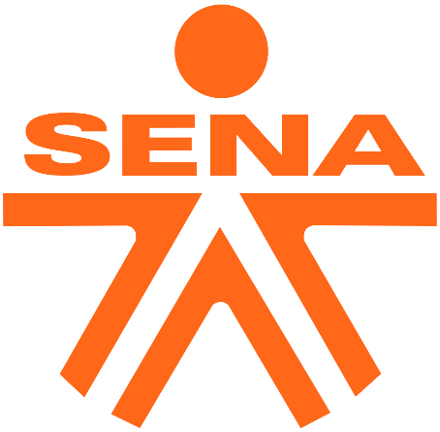

DIEGO ALEJANDRO MESA VASQUEZ

CENTER FOR AGROINDUSTRIAL TECHNOLOGIES

MEDELLIN

2023

An individual's trajectory in their academic and work context, along with their plans, actions, and solutions, reflect not only their dedication, but also their ability to adapt and be flexible in the environments of leadership and professional responsibility. The ability to evolve and learn from experiences is critical in an ever-changing world.

As one progresses, it is crucial to maintain a proactive attitude towards continuous learning and self-improvement. Adaptability becomes an invaluable tool, allowing strategies and approaches to be adjusted according to the demands of the work and academic environment. This ability to embrace change not only strengthens professional effectiveness, but also the ability to lead teams in an inclusive and dynamic way.

Flexibility and adaptability are not only personal traits, but also pillars of a resilient organizational culture. By applying innovative solutions and being willing to adjust course when necessary, you build a strong foundation for career growth and long-term success. In short, the combination of experience, adaptability and effective leadership becomes a powerful driving force in any work and academic context, making it easier to achieve goals and face challenges with confidence and determination.

In my academic experience, I have demonstrated my adaptability by tackling a variety of disciplines and study approaches. I have learned to incorporate multiple perspectives and approaches into my thinking, which has allowed me to be an effective leader in cross-functional teams.

In my work environment, I have taken on leadership roles where flexibility and adaptability are crucial to maintaining agility in an ever-changing business world. My track record includes the successful implementation of innovative solutions that have improved operational efficiency and quality of work.

My future plans include continuing to develop my leadership skills and leveraging technology and best practices to achieve outstanding results. The ability to adapt and the willingness to face new challenges are fundamental principles that guide my path to success in an ever-evolving world of work and academia.

My experience and track record reflect a firm commitment to flexibility, adaptability and the continuous search for effective solutions in leadership and professional responsibility. These qualities are essential to thrive in dynamic and challenging contexts.

https://www.spreaker.com/user/17408658/trajectory-in-my-work-context